1. b. I/O
2. c = a + b
3. a. 10, 10

Count print increment count<10 ?

0 Hello World 1 yes

1 Hello World 2 yes

2 Hello World 3 yes

…

9 Hello World 10 no

10 times 10

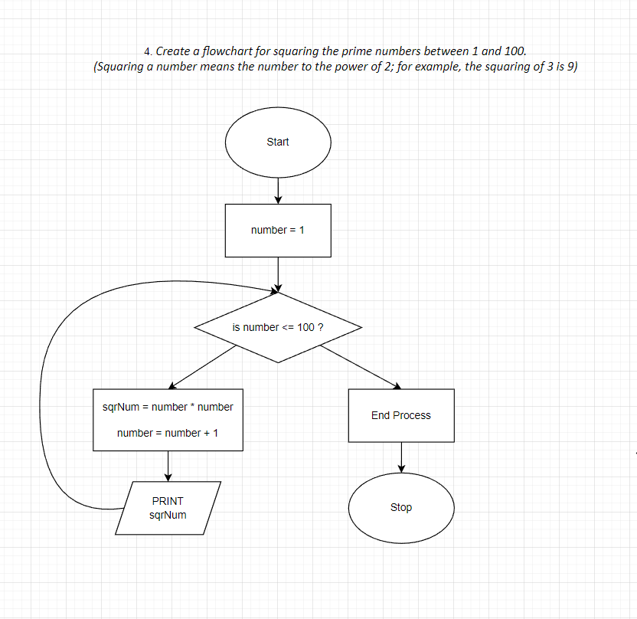

1. 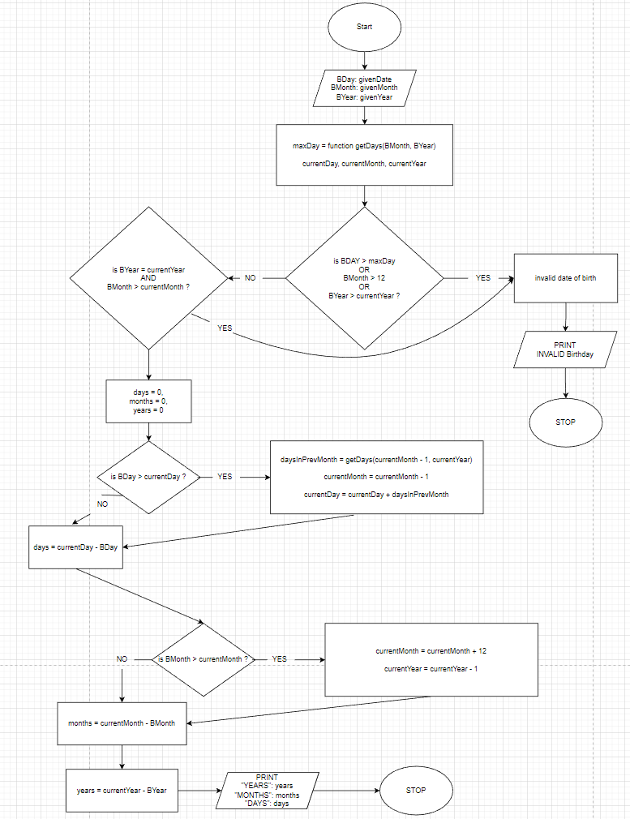

1. 